Chapter 14 Name:____________
Work, Power, and Machines Mr. Rosener

Section 1: Work and Power

What Is Work?
- Recall that an object begins moving only when an ___________________ force acts on it.
- Work is done when a force acts on an object in the direction the object ____________.
- the __________ of force and distance
Work Requires Motion
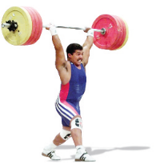
- For a force to do work on an
object, some of the force must act
in the same ____________ as the
object moves.
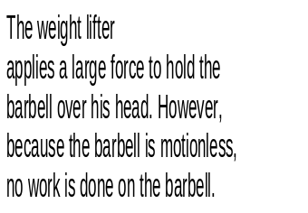
- If there is no ___________, no work
is done.

Work Depends on Direction
- The amount of work done on an object, if any, depends on the direction of the force and the direction of the _________.
- Any part of a force that ________________ act in the direction of motion does no work on an object
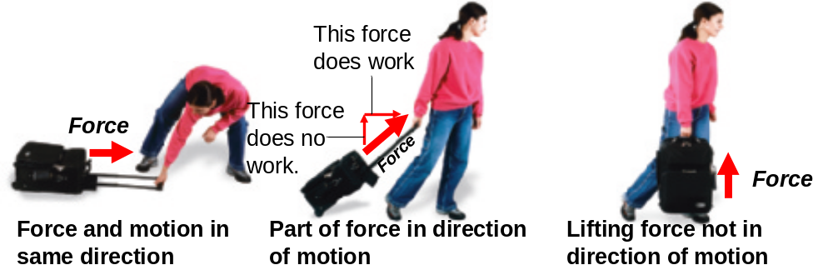

Calculating Work
- Formula

Units of Work
- The _____________ is the SI unit of work
- When a force of 1 newton moves an object 1 meter in the direction of the force, 1 joule of work is done.
- The joule is named after James Prescott Joule (1818–1889), a British scientist famous for researching the relationship between work and heat.
Using the Work Formula

A weight lifter who lifts a 1600-newton barbell 2.0 meters over his head. How much work had been done?

What Is Power?
- _____________ is the rate of doing work.
- Doing work at a faster rate requires more __________.
- To increase power, you can increase the amount of ________ done in a given ________, or you can do a given amount of work in less time.
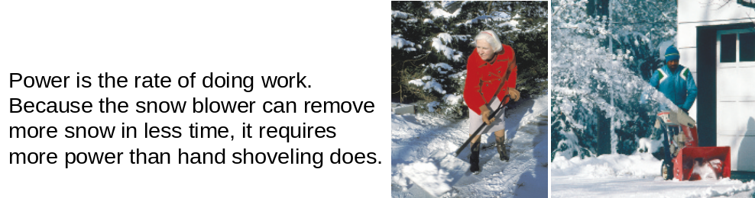

Calculating Power
- You can calculate power by dividing the amount of work done by the time needed to do the work.
- Formula:

Units for Power
- Scottish scientist, James Watt, was looking for a way to compare the power outputs of steam engines he had designed.
- The SI unit of power is the ________________
- equal to one joule per second


Your family is moving to a new apartment. While lifting a box 1.5 m straight up to put it on a truck, you exert an upward force of 200 N for 1.0 s. How much power is required to do this?

You lift a book from the floor to a bookshelf 1.0 m above the ground. How much power is used if the upward force is 15.0 N and you do the work in 2.0 s?

Section 2: Work and Machines

Machines Do Work
- A ______________ is a device that changes a force.
- Machines make work ___________ to do. They change the size of a force needed, the direction of a force, or the distance over which a force acts.
- They do not ____________ the amount of work done, they _______________ the work done
Increasing Force
- Each complete rotation of the jack handle applies a _________ force over a ___________ distance.
- You gain ________.
- However, what you gain in _________ you lose in ________.
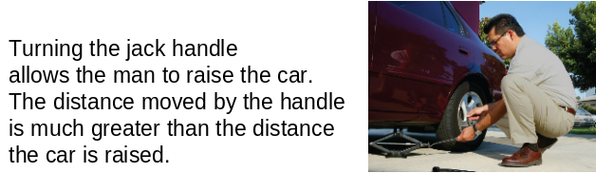

Increasing Distance
- Some machines decrease the applied __________, but increase the ___________ over which the force is exerted.
- What you gain in ___________, you lose in ___________.
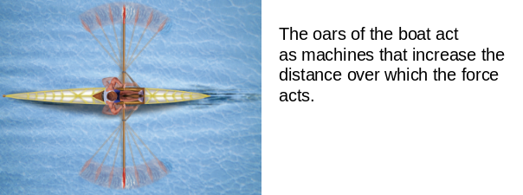

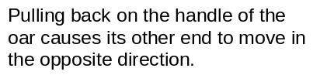

Changing Direction
- Some machines change the __________ of the applied force.
- So not only can machines change the amount of ________ and the ___________ the force acts through, but they can also change the _______________ of the force.

Work Input and Work Output
- Because of ______________, the work done by a machine is always ________ than the work done on the machine.
Work Input to a Machine
- The force you exert on a machine is called the ___________.
- The distance the input force acts through is known as the _____________________.
- The work done by the input force acting through the input distance is called the ___________________.
Work Output of a Machine
- The force that is exerted by a machine is called the _________________.
- The distance the output force is exerted through is the ___________________.
- The _____________ of a machine is the output force multiplied by the output distance.
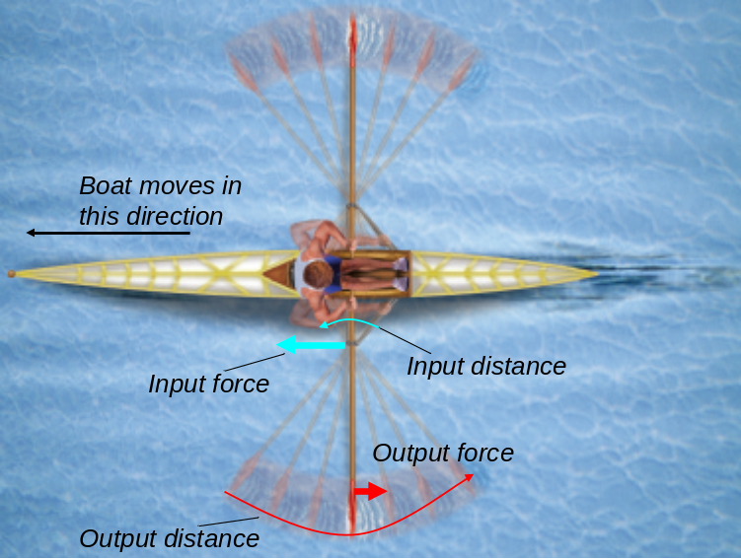

Section 3: Mechanical Advantage and Efficiency

Mechanical Advantage
The ________________________ of a machine is the number of times that the machine increases an input force.
Actual Mechanical Advantage
- The mechanical advantage determined by measuring the ____________ forces acting on a machine is the actual mechanical advantage.
- The __________ mechanical advantage (AMA) equals the ratio of the output force to the input force.
- Formula:

Ideal Mechanical Advantage
- The _________ mechanical advantage (IMA) of a machine is the mechanical advantage in the absence of friction.
- Because __________ is always present, the actual mechanical advantage of a machine is always ___________ than the ideal mechanical advantage
Calculating Mechanical Advantage
- Ideal mechanical advantage is easier to measure than actual mechanical advantage because it depends only on the ________ of the forces and the distances over which they act.
- Formula:

A student working in a grocery store after school pushes several grocery carts together along a ramp. The ramp is 3 meters long and rises 0.5 meter. What is the ideal mechanical advantage of the ramp?

A construction worker moves a crowbar through a distance of 0.50 m to lift a load 0.05 m off of the ground. What is the IMA of the crowbar?

The IMA of a simple machine is 2.5. If the output distance of the machine is 1.0 m, what is the input distance?

Efficiency
- Because some of the work input to a machine is always used to overcome ____________, the work output of a machine is always less than the work input.
- The percentage of the work input that becomes work output is the ________________ of a machine.
- Because there is always some ___________, the efficiency of any machine is always less than __________ percent.
- Efficiency is usually expressed as a ______________
- Formula:

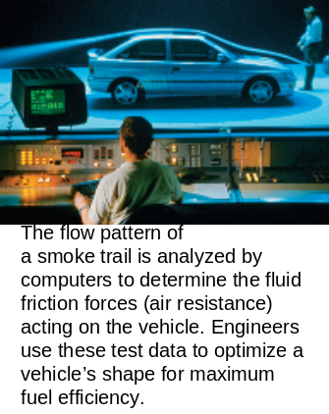

Reducing __________ increases the
efficiency of a machine

Section 4: Simple Machines
The six types of simple machines are the lever, the wheel and axle, the inclined plane, the wedge, the screw, and the pulley.
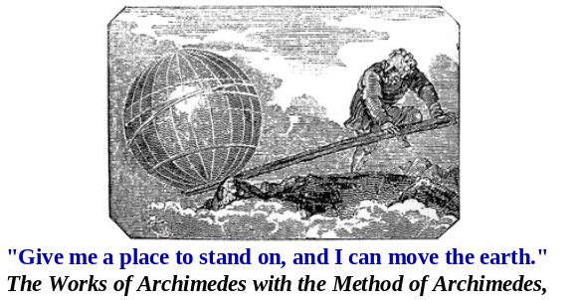
Levers

- A _____, a rigid bar that is free to move around a fixed point.
- The fixed point the bar rotates around is the ___________.
- Levers are classified into three categories based on the locations of the input force, the output force, and the fulcrum.
- The ________________ of a lever is the distance between the input force and the fulcrum.
- The ________________ is the distance between the output force and the fulcrum.
- There are three classes of Levers: 1st class, 2nd class, and 3rd class
Mechanical Advantage of a Lever
- To calculate the ideal mechanical advantage of any lever, __________ the input arm by the output arm.
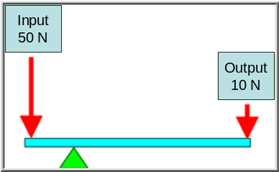

First-Class Levers
- The position of the ___________ identifies a first-class lever
- The ____________ of a first-class lever is always located between the input force and the output force.
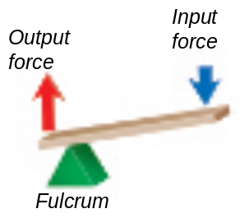
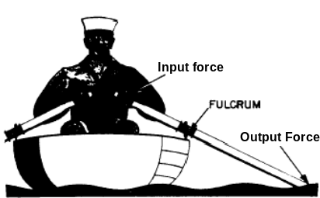

- Depending on the location of the fulcrum, the mechanical advantage of a first-class lever can be greater than 1, equal to 1, or less than 1.
- Examples of first-class levers include a seesaw, scissors, and tongs.
Second-Class Levers
- In a second-class lever the ____________ is located between the input force and the fulcrum.
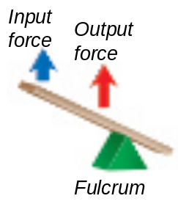
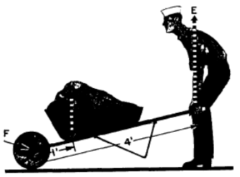

Third-Class Lever
- The _______________ of a third-class lever is located between the fulcrum and the output force.
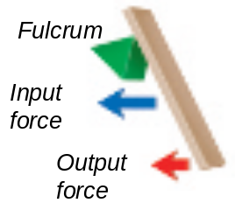
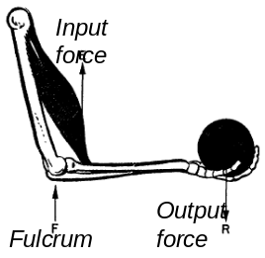

Wheel and Axle
- A _________________ is a simple machine that consists of two disks or cylinders, each one with a different radius.
- The wheel is the _________ object and the axle is the ______ object.
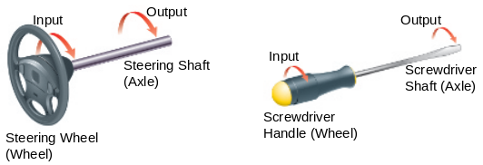

Mechanical Advantage of a Wheel and Axle
- To calculate the ideal mechanical advantage of the wheel and axle, divide the radius (or diameter) where the input force is exerted by the radius (or diameter) where the output force is exerted.
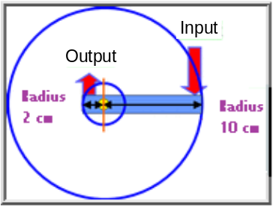

Pulleys
- A ___________ is a simple machine that consists of a rope that fits into a groove in a wheel.
- Pulleys produce an output force that is different in ________, __________, or _________, from that of the input force.
Three Types of Pulleys
- There are 3 types of pulleys: Fixed Pulley, Moveable Pulley, and Block and Tackle

Fixed Pulley
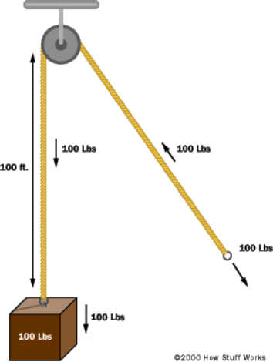
- A fixed pulley is a wheel attached in a _______ location.
- Fixed pulleys are only able to ___________ in place.
- The ____________ of the exerted force is changed by a fixed pulley, but the size of the _______ is not

Movable Pulley
- A movable pulley is attached to the ________ being moved rather than to a __________ location.  - The size of the _______ is changed not the dirction.  - If you are pulling up on the rope on the right with a force of 10 newtons, then both sections of the rope pull up with the same force of 10 newtons. | 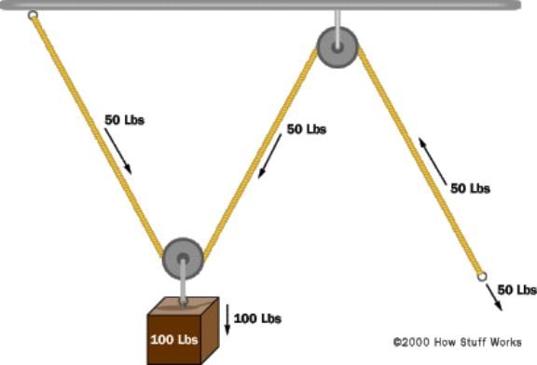
Pulley System (Block and Tackle)
- By combining fixed and movable pulleys into a pulley system, a large mechanical advantage can be achieved.
- The mechanical advantage that results depends on how the pulleys are _______________.

Mechanical Advantage of a Pulley
- The ideal mechanical advantage of a pulley or pulley system is equal to the number of __________ sections supporting the load being lifted.
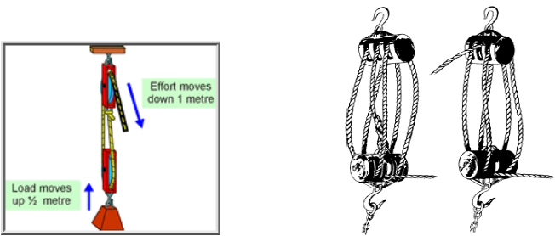

Inclined Planes
- An ___________________ is a slanted surface along which a force moves an object to a different elevation.
- No __________ parts
- The _________ slanted the inclined plane, the longer the _____________over which the force is exerted and the __________ the force is multiplied
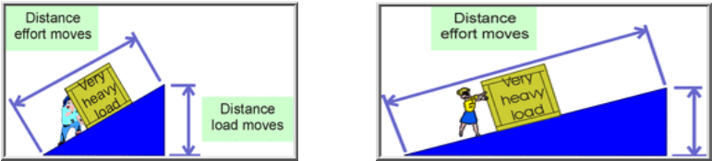

Mechanical Advantage of an Inclined Plane
- The ideal mechanical advantage of an inclined plane is the distance along the inclined plane divided by its change in height.
- Formula:

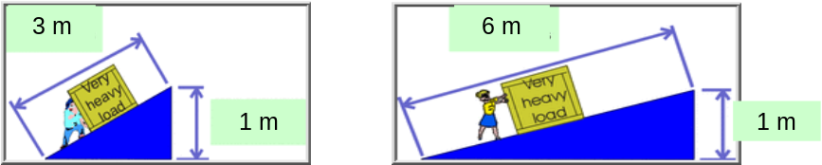

Wedge
- A _______ is a V-shaped object whose sides are two inclined planes sloped toward each other.
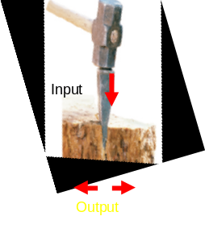
- An inclined plane that ________
- Most wedges are made
of ________ inclined planes

Mechanical Advantage of a Wedge
- The longer and thinner ________,
the greater the mechanical advantage
- How do you make a knife cut better?
- Sharpen it (make it _________ and __________)
Screw
- A ________ is an inclined plane wrapped around a cylinder.
- Multiplies force by acting through a ________ distance
- The ___________ the threads (
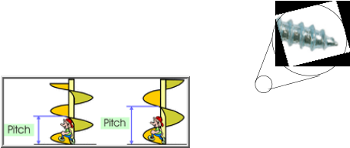
pitch), the longer the distance

Mechanical Advantage of a Screw
- The mechanical advantage of _________ increases when the threads are close together
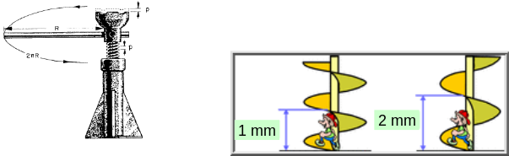

Compound Machines
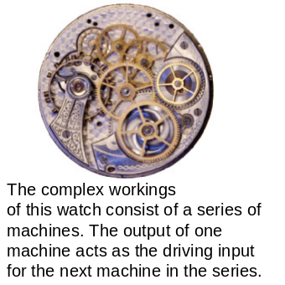
- A compound machine is a
combination of two or more
____________ machines
that operate together.

